Compartment creation with ORM Stack

Contents

1. Introduction 3
2. Workflow diagram to deploy the stack 3
3. Create stack for Compartment creation 4
4. Plan the Job 9
5. Apply the Job 10
6. Verify in the Console 11
7. Destroy the stack (if required) 12

Introduction

In Oracle Cloud Infrastructure (OCI), a compartment is a logical container used for organizing and isolating cloud resources. It is a fundamental building block of OCI's governance and access control model, which provides a structured way to manage resources, permissions, and policies within a cloud environment.
A compartment is similar to a folder or directory in a file system, and it can contain a specific set of resources, such as compute instances, block volumes, object storage buckets, virtual cloud networks, etc. It can also have its own set of policies and access controls that define who can access the resources within the compartment and what actions they can perform on those resources. Creates a new compartment in the specified compartment.

Workflow diagram to deploy the stack

Below diagram shows how the Terraform Artifact are applied in the OCI. While creating a ORM stack, using terraform deliverables Init, Plan and Apply is the flow to provision the resource in the OCI. We can have the deliverables in any of below.

- GitLab/GitHub Repo
- Bitbucket
- Can be in folder/.zip in the local disk
- Object Storage Bucket
- Can be in compartment
- Oracle provided Template


Create stack for Compartment creation

Pre-requisites:
- Provide the “root compartment name”
- As per below structure the compartments will be created

Sub-compartment-1 | Sub-compartment-2 | Sub-compartment-3
prod_hub
nonprod_hub
network
monitoring
security
nonprod | nonprod_dev | appdev
 |  | dbdev
 | nonprod_tst | apptst
 |  | dbtst
prod | appprod
 | dbprod

Go to OCI Console Developer Services Resource Manager Stacks select the compartment Create Stack

My Configuration Folder Browse Select the “compartments” folder that contains the artifacts Upload

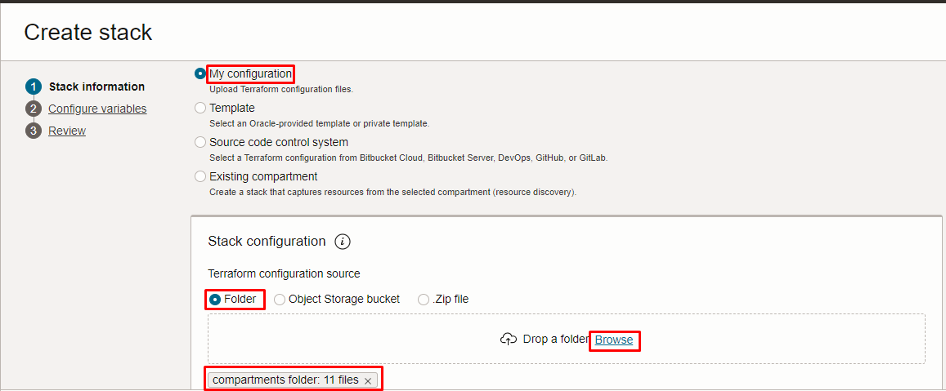
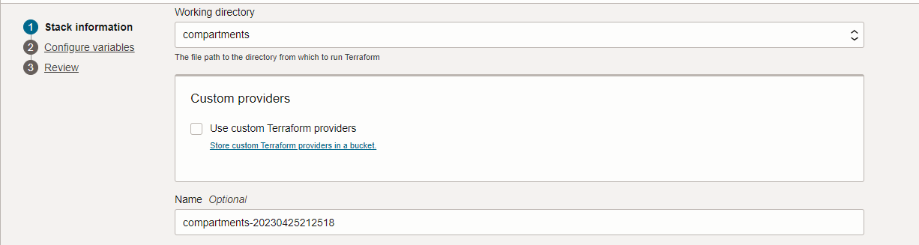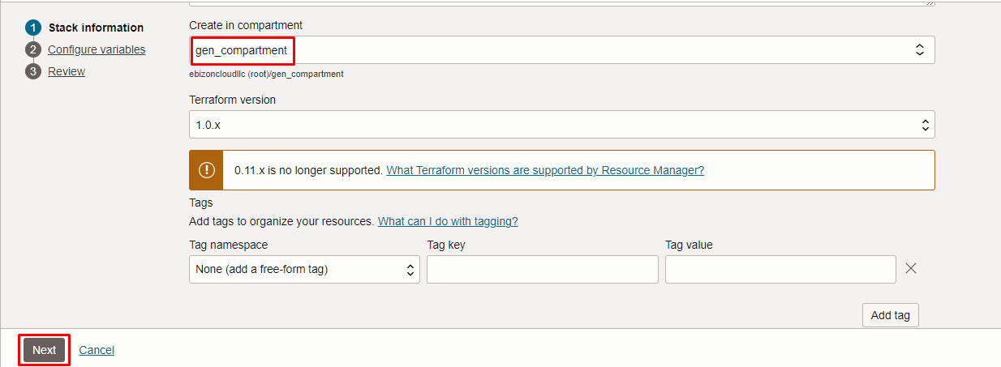

Click “NEXT”

Select the parameters as per the below screen,
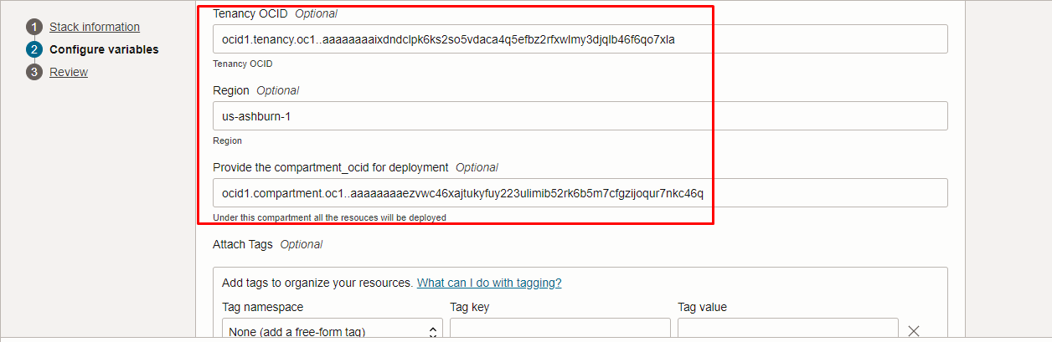
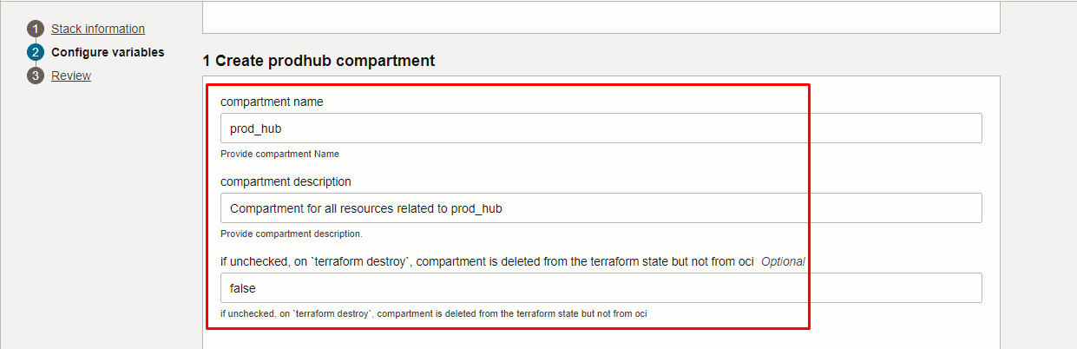
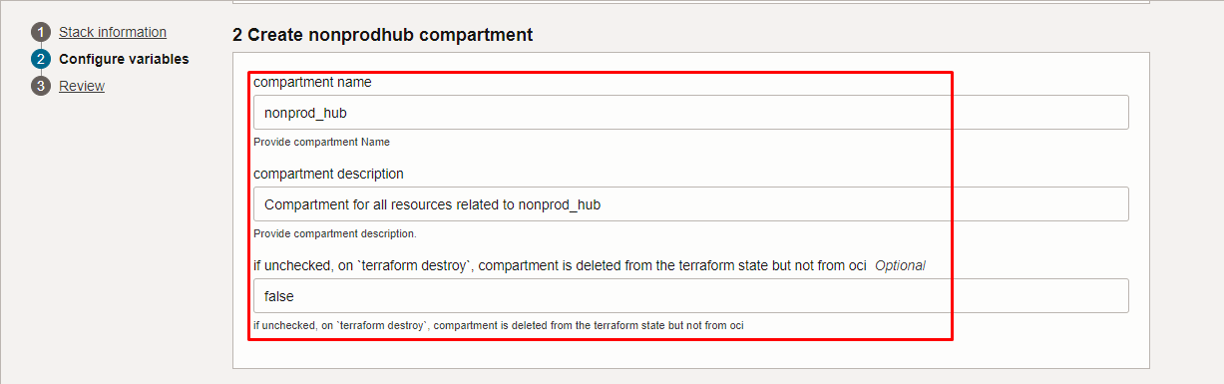
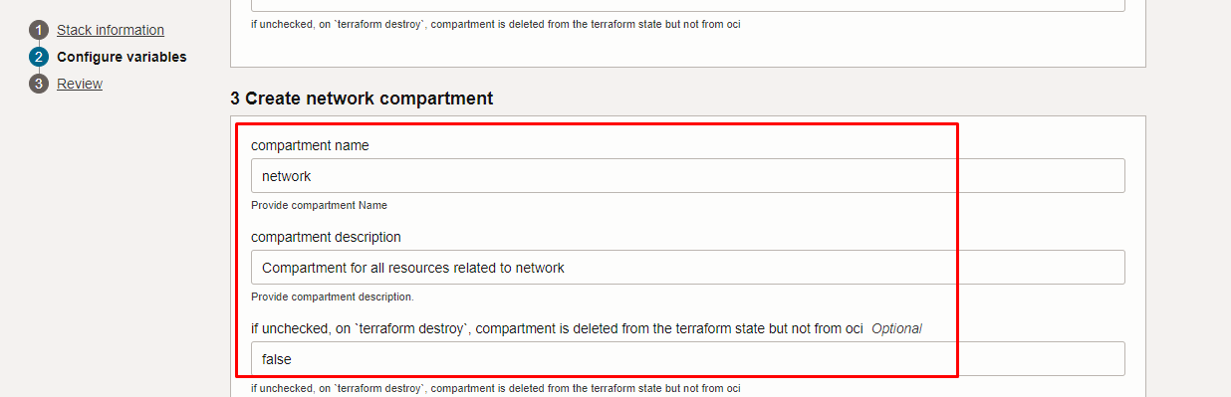
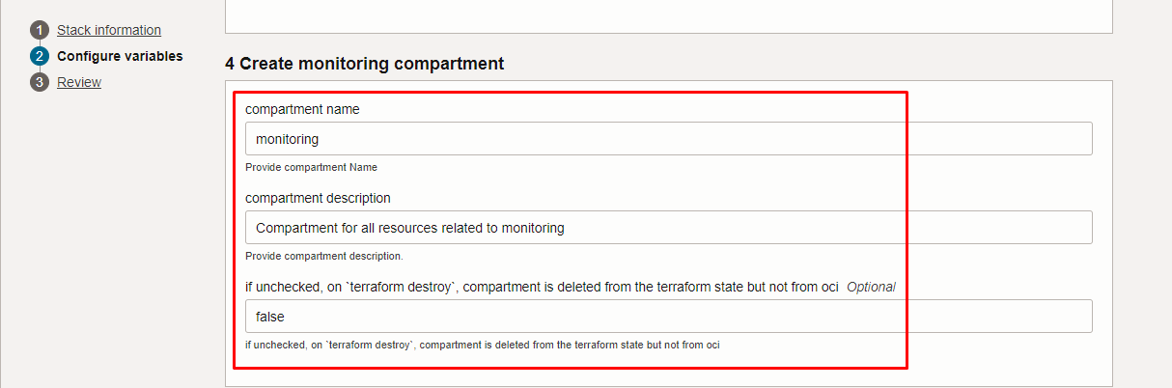
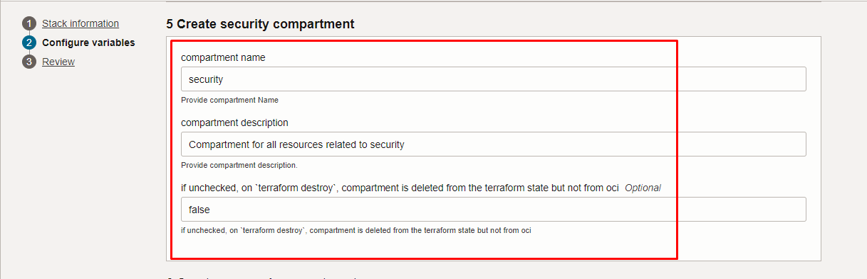
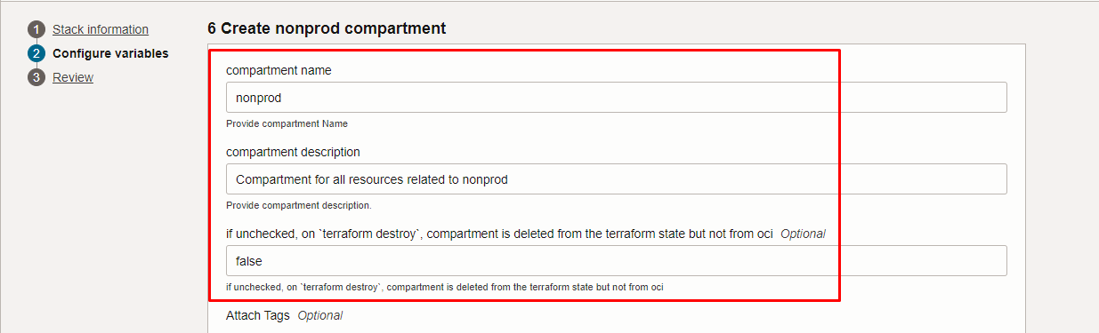
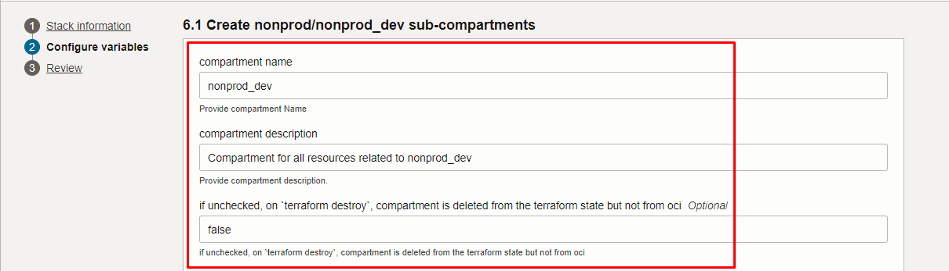
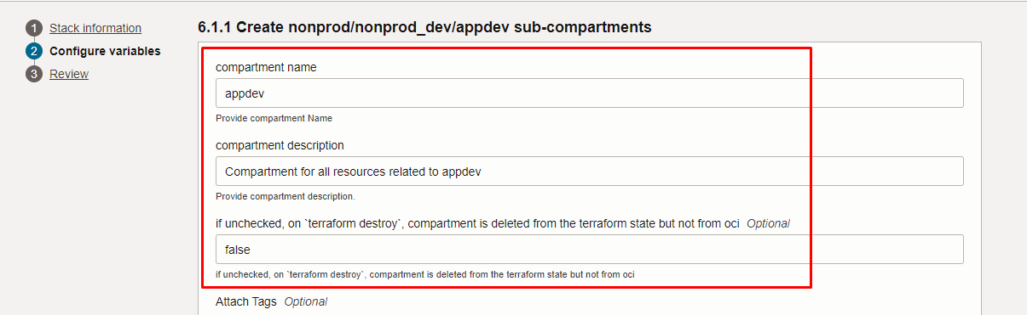
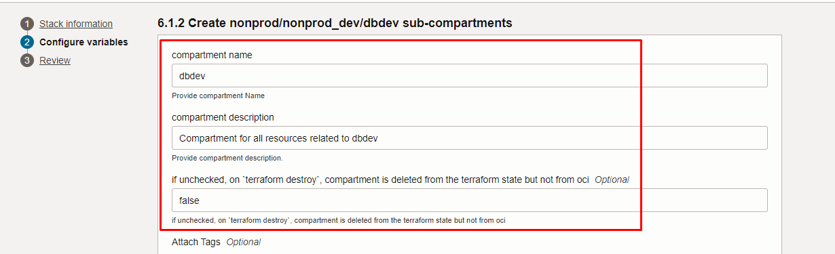
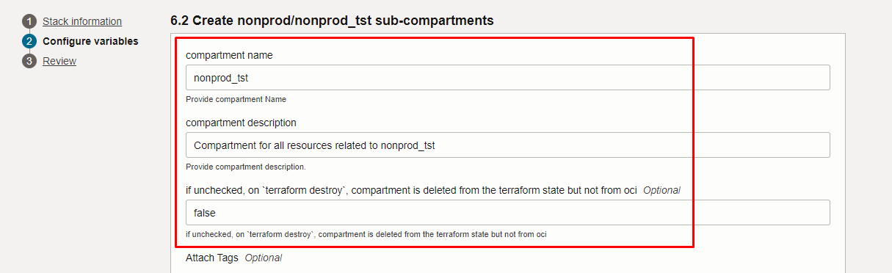
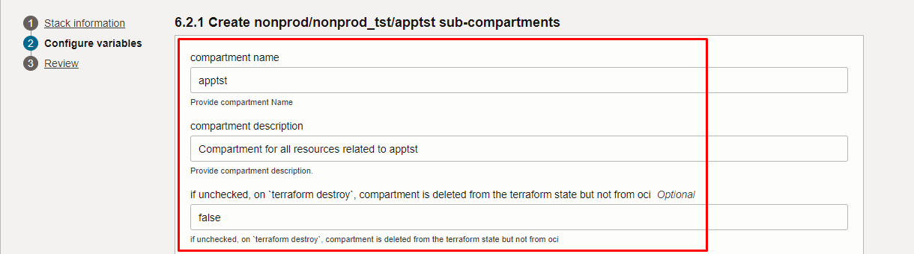
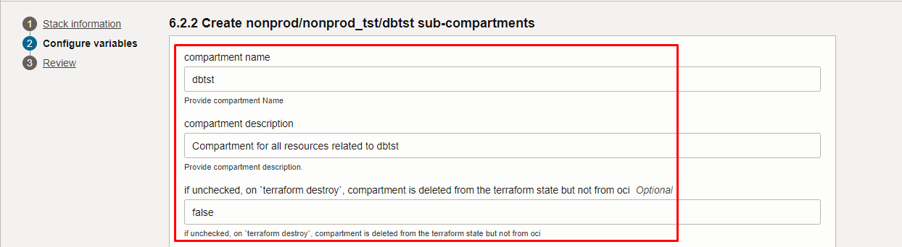
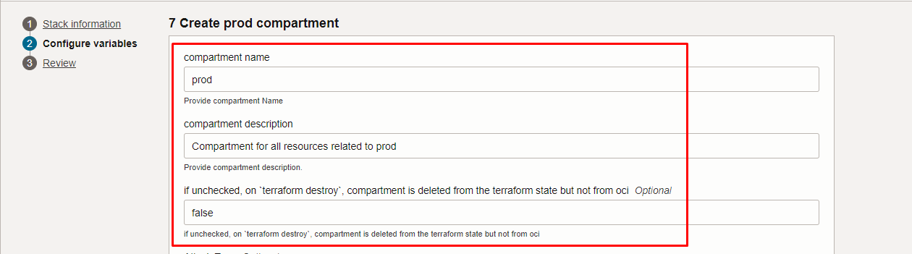
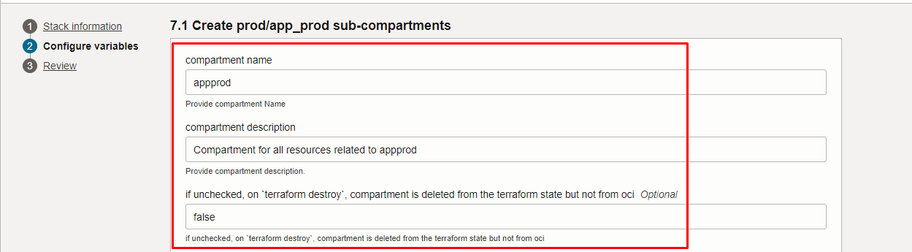
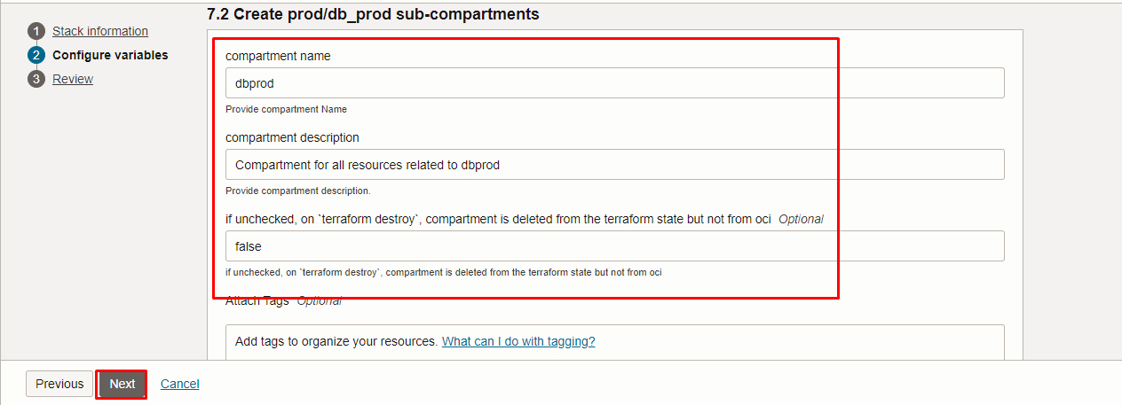

Note: select the right compartment to apply the stack in the OCI

Click “NEXT” Click “CREATE”

Plan the Job

Click the “Plan”

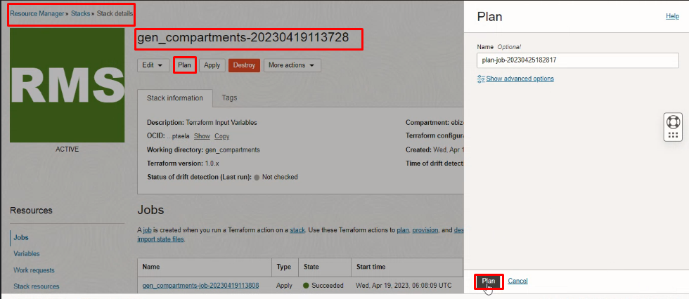
Verify the Plan is successful.

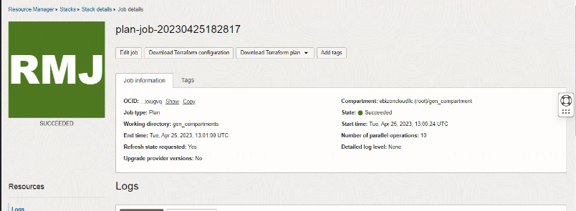

Apply the Job

Once the “plan” is success, now click “Apply”

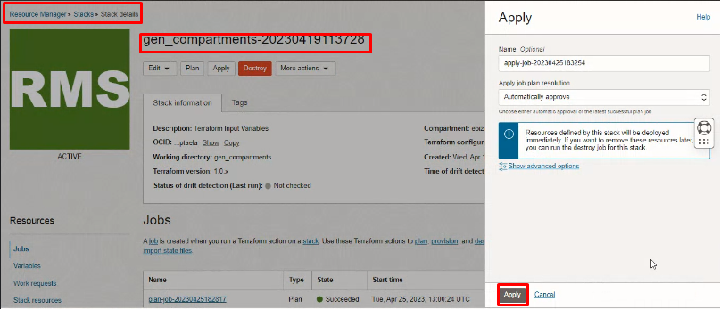

Verify the Apply is successful.

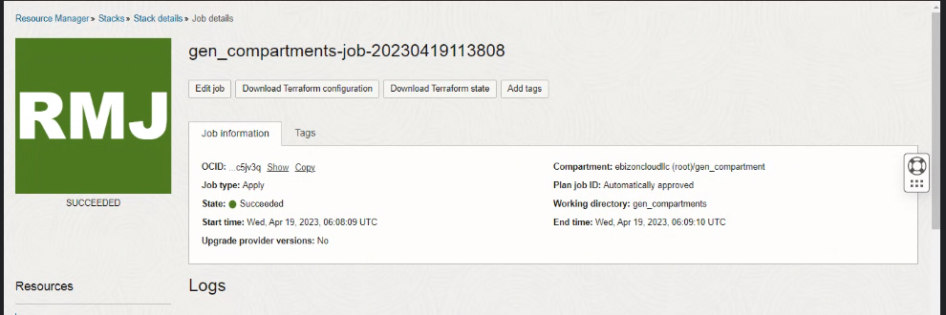

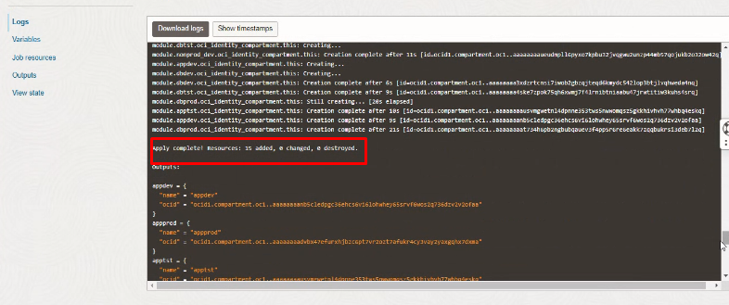

Verify in the Console

Go to OCI Console Identity & Security Compartments select the root compartment (example) gen compartment

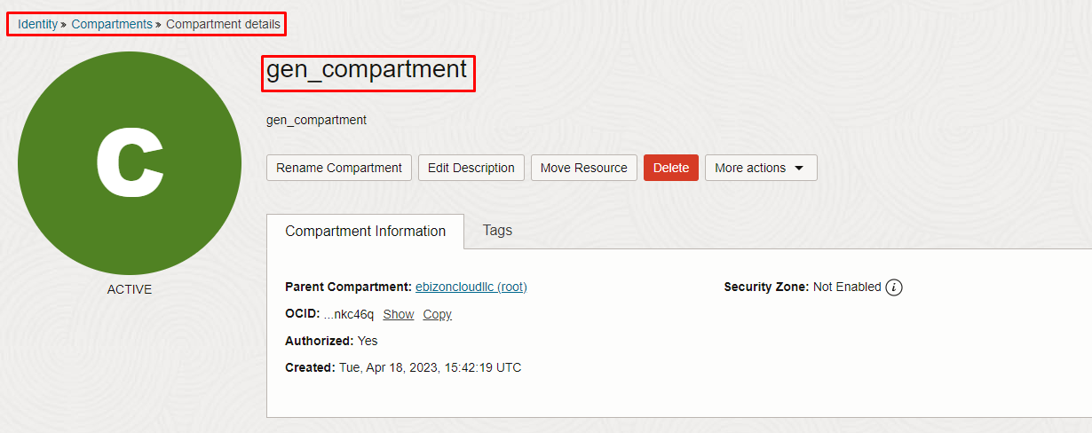

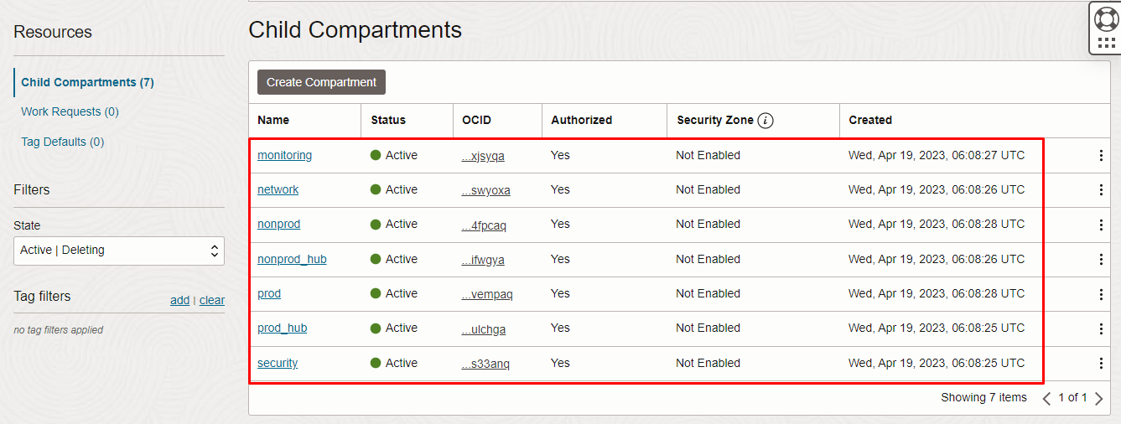

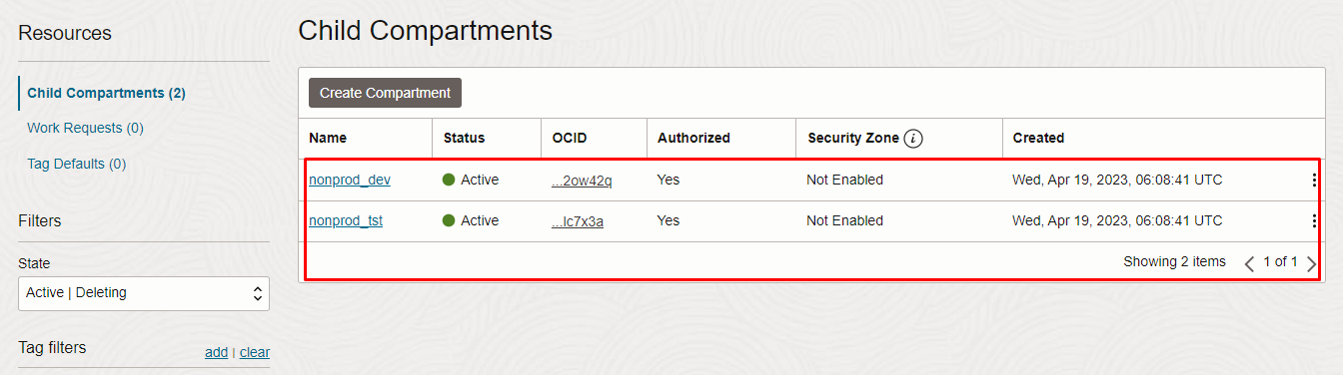

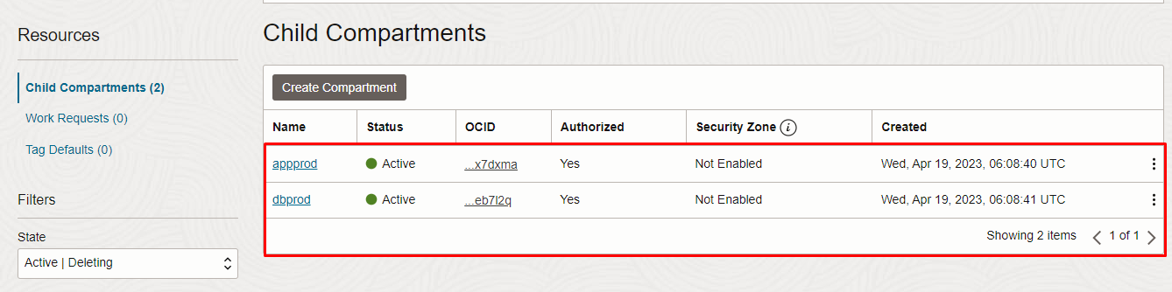

Destroy the stack (if required)

Create a destroy job in Resource Manager to release resources associated with a stack and clean up the tenancy. Once destroyed data cannot be recovered from resources.

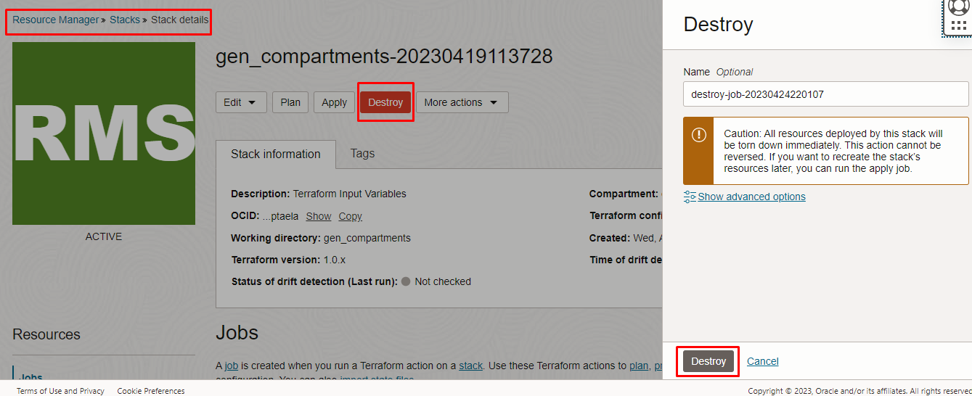

# END #

